Widely tunable actively mode-locked Bi-doped fiber laser operating in the O-band
N. K. Thipparapu, Shaiful Alam, Yu Wang, P. Shankar, David J. Richardson, and Jayanta K. Sahu
Abstract— Here, we propose an all-fiber actively mode-locked Bismuth (Bi)-doped fiber laser based on the use of an acousto-optic modulator. The mode-locked Bi-doped fiber laser produces 13ns pulses with a repetition rate of 1.683MHz at 1340nm. Higher harmonic mode-locking is achieved simply by changing the operating frequency of the acousto-optic modulator. The output power of the laser is 7mW and this is further amplified to 101mW using an external Bi-doped fiber amplifier. A peak power of 4.6W with a pulse energy of 60nJ is achieved after the master oscillator power amplifier. The stability of the laser is studied using an RF spectrum analyzer and an SNR of more than 60dB at the fundamental frequency of 1.683MHz was recorded. Furthermore, wavelength tuning of the Bi-doped fiber laser is explored and demonstrated from 1300 to 1370nm.

Index Terms— Bismuth, optical fibers, Fiber lasers, Laser mode locking

INTRODUCTION
P
ULSED fiber lasers operating in new wavelength bands are of significant importance due to increased applications in medicine, metrology, material processing, and optical communications [1-3]. Pulsed fiber lasers in the bands around 1, 1.5 and 2µm have been demonstrated using rare-earth (RE)-doped fibers such as Yb, Er, and Tm or Ho respectively [4, 5]. However, the regions between 1.18 to 1.45µm and 1.6 to 1.8µm cannot be addressed, or are at best extremely challenging to address, even in part, using RE-doped silica fibers. Recently, Bismuth (Bi)-doped fibers (BDFs) have been explored to develop optoelectronic devices in the 1.18-1.8µm wavelength range thanks to the host-dependent optical properties of the bismuth ion. Optical sources around 1.18, 1.3, and 1.45µm have been reported in BDFs co-doped with aluminum (Al), phosphorous (P), and germanium (Ge), respectively [6-9]. More recently, optical sources around 1.7µm have also been reported using high Ge (>50%) BDFs [10, 11]. Among the wavelength bands covered by BDFs the 1.3µm band is significant due to the low intrinsic dispersion of silica fiber at this wavelength and its use in optical fiber communications [12, 13]. Furthermore, major constituents of biological tissues such as water, oxyhemoglobin, and melanin have minimum transmission loss windows in the 1.3µm band resulting in medical applications [14, 15].
Both active and passive mode-locking techniques can be used to generate short optical pulses around 1.3µm using Bi-doped fiber lasers (BDFLs). Various pulsed BDFLs in the 1.3µm band were reported by exploiting passive mode-locking techniques either by using natural or artificial mode-locking elements such as Single-Walled Carbon Nanotubes (SWCNTs), Semiconductor Saturable Absorber Mirrors (SESAMs), and Nonlinear Amplifying/Optical Loop Mirrors (NALM/NOLMs) [16-18]. However, there are no reports on actively mode-locked Bi-doped fiber lasers (ML-BDFLs). Recently, a Q-switched BDFL operating at 1.33µm was demonstrated using an acousto-optic modulator (AOM) [19]. Multi-peak pulses were observed with the duration of the highest peak being 80ns and with a pulse energy of 11.5µJ. AOM based mode-locking techniques have been well known for years in RE-doped (Er, Yb and Tm) pulsed fiber lasers [20, 21], however, their application to novel BDFs has not received attention. The use of actively mode-locked pulsed laser schemes provides a wide range of benefits in comparison to passive ones including ready control of repetition rate, pulse energy, and average power. In this paper, we demonstrate an actively mode-locked Bi-doped all-fiber laser operating in the 1.3µm band using an AOM. The laser emits 13ns pulses with a repetition rate of 1.683MHz at 1340nm. The output power of the laser is 7mW and this is further increased to 101mW with an external Bi-doped fiber amplifier (BDFA).

EXPERIMENTS AND RESULTS
The BDF used has core and cladding diameters of 9μm and 125μm, respectively. The index difference (Δn) between the core and cladding was 0.004. The cut-off wavelength (λc) of the fiber was measured to be 980nm. The absorption at the 1240nm pump wavelength was 0.59dB/m while the unsaturable loss (UL) was ~15%. The experimental setup of the actively ML-BDFL is shown in Fig. 1. Two fiber pigtailed laser diodes (LDs) operating at 1240nm, each with an output power of nearly 400mW, were used in a bidirectional pumping scheme. Isolators (ISO) were used to protect the pumps. Two wavelength division multiplexers (WDMs) were used to combine and separate the pump and signal wavelengths, respectively. First, a ring cavity laser was constructed using an intracavity circulator (CIR) coupled to a fiber Bragg grating
(FBG) for wavelength control. The FBG has a centre wavelength of 1340nm with a reflectivity of 98% and a full width at half maximum (FWHM) of ~ 0.5nm. The laser output is extracted using a 95/5 coupler with the 5% arm being the output port. An additional 99/1 coupler was added to the 5% port to measure the optical spectrum and pulse profile simultaneously. A fiber pigtailed AOM (NEOS 26035-2-1.55-FO) with 35MHz operating frequency (and associated frequency shift) is used as the active mode-locking element. The AOM insertion loss is optimized for a laser operating wavelength of 1.34μm and is measured as 3.8dB. The rise and fall times of the AOM (as measured at 1340nm) were found to be 45ns and 80ns, respectively. The total length of the cavity is around 123m, out of which 110m is the BDF and 13m is the length of the fiber attached to the various passive fiber components. An optical spectrum analyzer (OSA-YOKOGAWA AQ6370), oscilloscope (2.5GHz), InGaAs photodetector (5GHz), and a 3GHz radio frequency (RF) spectrum analyser (N9320B) were used to measure the characteristics of the actively ML-BDFL.
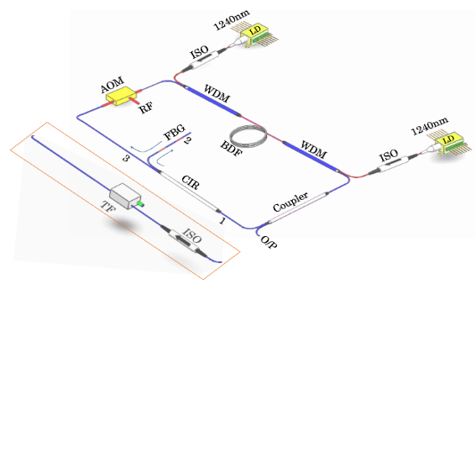
Fig. 1. Schematic of the FBG-based active ML-BDFL (inset; isolator and tunable filter that were used as replacement for the circulator and FBG to construct a tunable BDFL).
Initially, we observed mode-locked pulses with an optical spectrum centred at 1340nm, as defined by the FBG, for a total pump power of 786mW (Forward: 394mW, Backward: 392mW) and with the AOM driven at the cavity round trip frequency of 1.683MHz (with an opening time of 80ns). The onset of robust mode-locking was observed for a pump power of 233mW and remained stable up to the maximum available total pump power. The output power increased with pump power and a maximum output power of 7mW was recorded. A pulse duration of 13ns was measured as shown in Fig. 2. at the maximum pump power, while the inset shows the corresponding pulse train at the fundamental repetition rate of 1.683MHz. The use of a relatively long length of BDF leads to lower repetition rates and longer pulse durations as compared to conventional RE-doped active mode-locked fiber lasers. Fig. 3 (a) shows the optical spectrum of the BDFL under both CW and mode-locked operation as measured with a resolution bandwidth (RBW) of 0.02nm. The optical spectrum broadened under mode-locked operation as compared to CW operation resulting in a spectral bandwidth of 1nm.
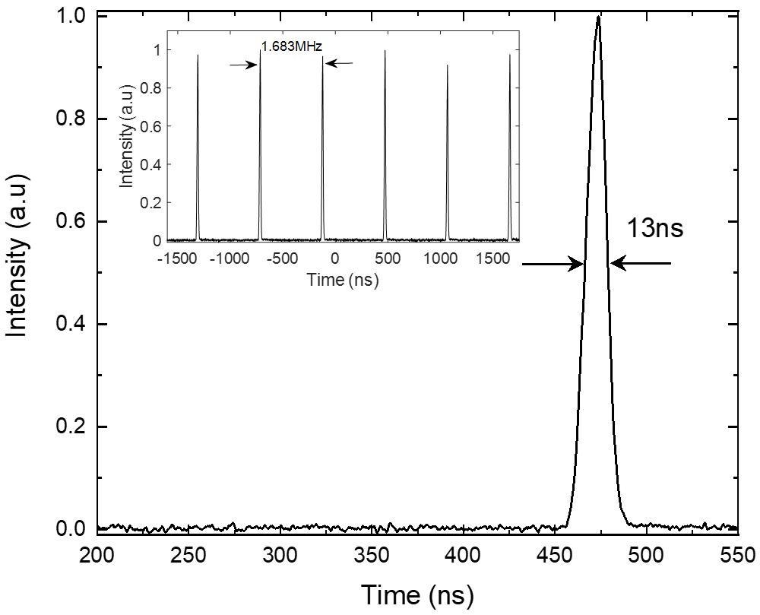
Fig. 2. Single pulse with a pulse duration of 13ns and the pulse train at a repetition rate of 1.683MHz (inset) of ML-BDFL.
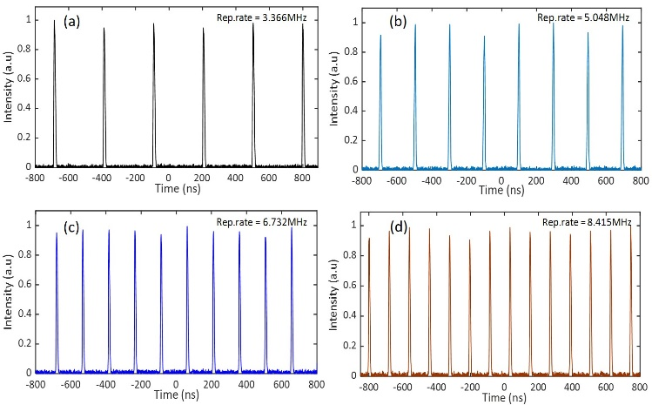
Fig. 5. Pulse trains of the harmonically ML-BDFL with repetition rates of (a) 3.366MHz, (b) 5.048MHz, (c) 6.732MHz, and (d) 8.415MHz.

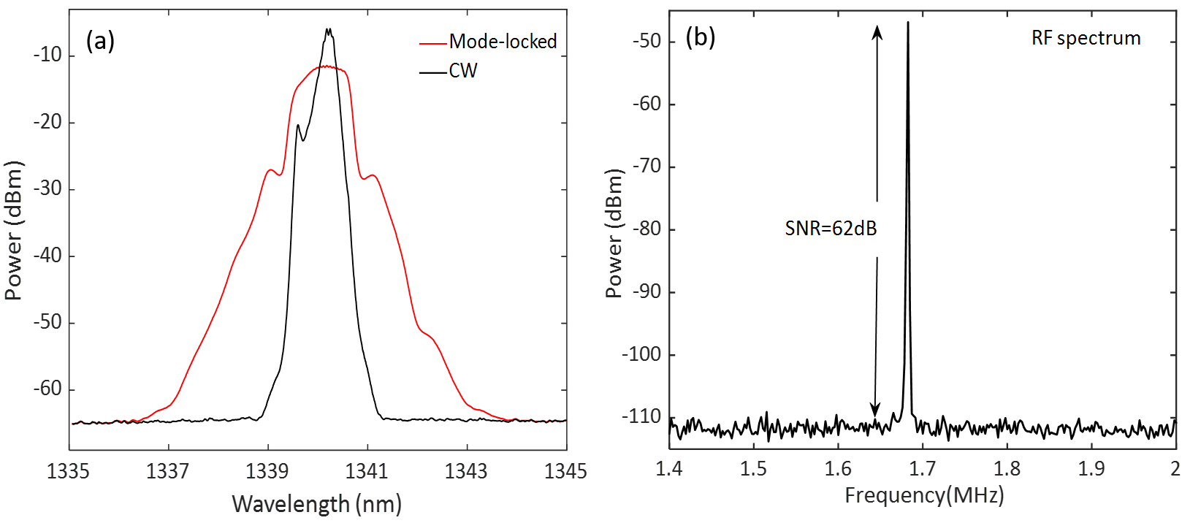
Fig. 3. (a) Optical spectra in CW and mode-locked operation of the BDFL, (b) Radio-frequency spectrum of the ML-BDFL pulse train.

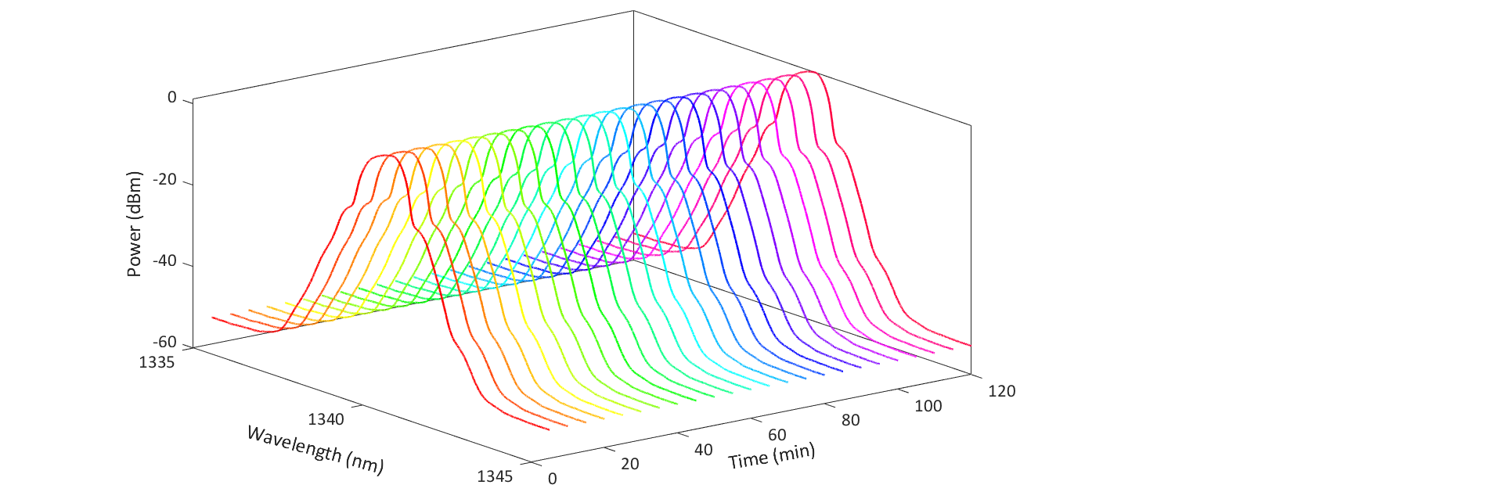
Fig. 4. Optical spectrum of the ML-BDFL over a 2 hours’ time span

We also measured the Radiofrequency (RF) spectrum of the ML-BDFL to evaluate the stability of the pulse train and this is plotted in Fig. 3 (b). The RF spectrum measured with a RBW of 10Hz, indicates a Signal-to-Noise Ratio (SNR) of 62dB at the fundamental frequency of 1.683MHz. To further demonstrate the stability of the ML-BDFL we continuously monitored the optical spectrum over a 2-hour time span and the result is shown in Fig. 4. The measured optical spectra evidence the excellent repeatability and stability of the laser.
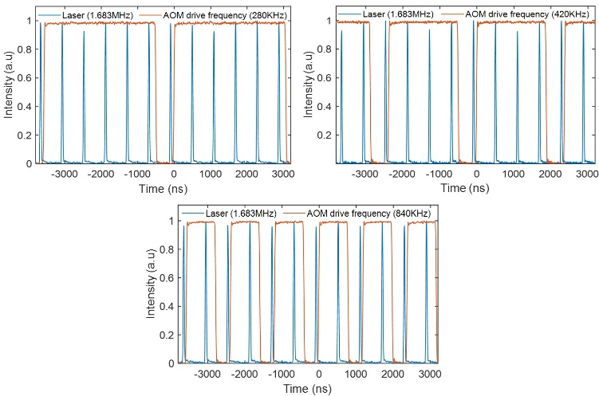
Fig. 6. Pulses (blue) per cycle for different AOM modulation frequencies and corresponding duty cycles are: (a) 280kHz (86%), (b) 420kHz (79%), (c) 840kHz (66%). (Orange lines show the voltage applied to the AOM 1V=on, OV = off)

We have also demonstrated harmonic mode-locking by changing the modulation frequency of the AOM. This is advantageous in applications where flexibility in repetition rate is required [22]. The harmonically mode-locked pulse profiles for repetition rates of 3.366MHz, 5.048MHz, 6.732MHz, and 8.415MHz (with the same AOM opening time of 80ns) are shown in Fig. 5. In the case of harmonic mode-locking the output pulse duration slightly reduced with increasing frequency and varied between 10-8ns. The measured RF spectra for the higher harmonic mode-locked pulses showed an SNR of
more than 50dB in all cases.
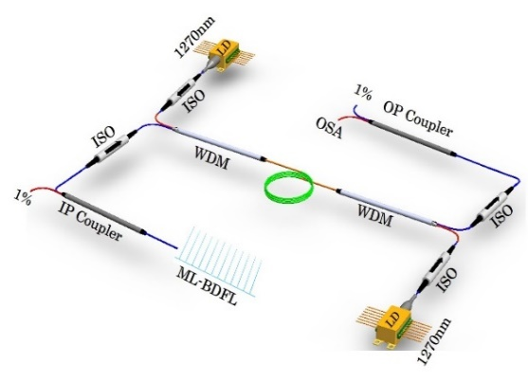
Fig. 8. Schematic of the boxed-up BDFA

Interestingly, we observed that when we set the AOM drive frequency to a subharmonic of the cavity round trip frequency (RTF) we were also able to observe pulse trains at the RTF. The number of pulses appearing in each AOM modulation cycle scaling with sub-harmonic number. Fig. 6 shows examples of the multiple pulses within one cycle for different AOM modulation frequencies. Here it was seen that 6, 4 and 2 pulses appear per modulation cycle corresponding to 280 kHz, 420 kHz, and 840kHz drive frequencies with a constant output pulse duration of 32ns.
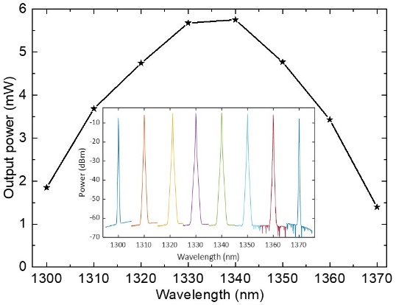
Fig. 7. Output power as a function of the operating wavelength of the tunable ML-BDFL (inset shows the optical spectra of the tunable ML-BDFL over the
tuning range from 1300 to 1370nm).

We note that two distinct forms of AOM-based mode-locking are in principle possible in our fiber laser - active mode-locking based on amplitude modulation (AM) and frequency-shifted feedback (FSF) mode-locking. In AM mode-locking the AM that occurs each round trip serves to add sidebands to each oscillating cavity mode. If this modulation frequency is equal to the cavity mode spacing the sidebands lock the phase of the cavity modes and this ultimately leads to pulse formation. In the FSF technique, the frequency of the circulating light is up-shifted each round trip and nonlinearity and filtering combine to favour pulsed over continuous-wave laser operation [23, 24]. In our experiments we found that amplitude modulation of the AOM at fundamental and harmonics of the cavity round trip frequency leads to mode-locking at fundamental and harmonic repetition rates. Whereas observations of multiple stable pulses within one cycle with different AOM drive frequencies are possible indicator of FSF mode-locking. For these cases, we always needed to drive the AOM at precise subharmonics of the cavity round trip frequency i.e. it was not possible to get FSF feedback mode-locking with the AOM constantly on. We thus contend that pulse formation in our cavity can, in certain conditions at least, involve an interplay of both active and frequency-shifting effects.
Furthermore, to demonstrate the wavelength tuning characteristics of the active ML-BDFL we replaced the circulator and FBG with an isolator and a tunable filter (TF) operating in the O-band, as shown in the inset of Fig. 1. The TF had an insertion loss of 1.5dB with a FWHM of 0.5nm. The isolator ensures unidirectional operation whereas the tunable filter is used to tune the laser operating wavelength. The output power variation with wavelength of the tunable ML-BDFL is shown in Fig. 7. A maximum output power of around 5.7mW was obtained at 1340nm at the fundamental repetition rate of 1.628MHz, while the power at the edges was around 1.5mW. Optical spectra from the tunable ML-BDFL are shown in the inset of Fig. 7. A pulse duration of 7.5ns is measured at 1340nm and 10ns at both edges of the spectrum. The reduction in repetition rate is due to the additional cavity length introduced by the isolator and the tunable filter. Finally, to increase the output power of the ML-BDFL, an in-house built, fully boxed up BDFA, was used as an external amplifier and the schematic is shown in Fig. 8. The 1% port of the additional 99/1 coupler was used to monitor the output of the ML-BDFL, while the 99% port was used as an input to the BDFA. The BDFA was bidirectionally pumped with two 1270nm pump LDs with a maximum total pump power of 715mW. Here again, two WDMs were used to combine and separate the pump and signal at the input and output ends, respectively. Isolators at the input and output ports of the amplifier were used to avoid back reflections into the amplifier as well as to the cavity of the ML-BDFL. Two additional isolators were used to protect the 1270nm pumps from any unabsorbed counter-propagating pump light. The 212m BDF used in the amplifier was different from the fiber used for the ML-BDFL. This BDF has core and cladding diameters of 12 and 125μm, respectively. The UL in this fiber was ∼13%. Figure 9 shows the amplified signal output power with seed power for a fixed total pump power of 715mW. The master oscillator power amplifier (MOPA) output power increased with seed power and reached a maximum saturated output power of 101mW. In a second experiment, as shown in the inset of Fig. 9., we have used 50% of the output power i.e. 3.5mW from the FBG-based ML-BDFL operating at 1340nm as the seed power to the MOPA. The MOPA output power increased linearly up to a maximum of 101mW and is limited by the maximum available pump power of 715mW. The slope efficiency is estimated to be 20%. Spectral and pulse profiles measured at the output of the MOPA showed that no noticeable distortion was introduced in the 212m long BDF. The corresponding peak power and energy were 4.6W and 60nJ, respectively.
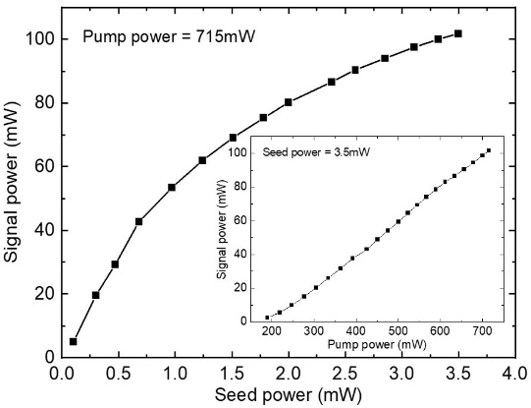
Fig. 9. Amplified signal power variation with seed power at a fixed total pump power of 715mW (inset shows the MOPA output power with pump power for a fixed seed power of 3.5mW from the FBG-based ML-BDFL operating at a wavelength of 1340nm).

Conclusion
In conclusion, we have demonstrated a ML-BDFL operating at 1340nm. The ML-BDFL produced 13ns pulses at the fundamental cavity repetition rate of 1.683MHz. Higher harmonic mode-locking was also achieved by changing the modulation frequency of the AOM. The output power of the laser was 7mW and this was further amplified to 101mW using an external BDFA. A peak power of 4.6W and pulse energy of 60nJ were achieved after the MOPA. The stability of the laser was studied using an RF spectrum analyzer and an SNR of 62dB at the fundamental frequency of 1.683MHz was recorded. Moreover, the tunable nature of the active ML-BDFL was explored and stable operation was demonstrated from 1300-1370nm. We believe that such a widely tunable actively ML-BDFL should be of interest in numerous fields including medicine, spectroscopy, and imaging.

Acknowledgment
The data for this letter can be accessed at the University of Southampton Institutional Research Repository doi: https://doi.org/10.5258/SOTON/D1754.

References
- M. E. Fermann and I. Hartl, “Ultrafast fiber lasers,” Nat. Photonics, vol. 7, no. 11, pp. 868–874, 2013.
- S. Taccheo, “Fiber lasers for medical diagnostics and treatments: State of the art, challenges and future perspectives,” Proc. SPIE, vol. 10058, pp. 1005808, 2017.
- D. J. Richardson, J. Nilsson, and W. A. Clarkson, “High power fiber lasers: current status and future perspective,” J. Opt. Soc. Am. B, vol. 27, no. 11, pp. B63–B92, 2010.
- M. N. Zervas and C. A. Codemard, “High power fiber lasers: a review,” IEEE J. Sel. Top. Quantum Electron, vol. 20, no. 5, pp. 219–241, 2014.
- M. J. F. Digonnet, ed., Rare-Earth-Doped Fiber Lasers and Amplifiers, 2nd ed. (Marcel Dekker, New York, 2001).
- N. K. Thipparapu et al., "1120 nm diode-pumped Bi-doped fiber amplifier," Opt. Lett., vol. 40, no. 10, pp. 2441-2444, 2015.
- N. K. Thipparapu et al., “Bi-doped fiber amplifier with a flat gain of 25 dB operating in the wavelength band 1320-1360 nm,” Opt. Lett., vol. 41, no. 7, pp. 1518–1521, 2016.
- I. A. Bufetov et al., “Bi-doped optical fibers and fiber lasers,” IEEE J Sel. Top. Quantum Electron., vol. 20, no. 5, pp. 0903815, 2014.
- N. K. Thipparapu et al., "Bi-doped fiber amplifiers and lasers [Invited]," Opt. Mater. Express, vol. 9, no. 6, pp. 2446-2465, 2019.
- S. V. Firstov et al., "Watt-level, continuous-wave bismuth-doped all-fiber laser operating at 1.7μm," Opt. Lett., vol. 40, no. 18, pp. 4360-4363, 2015.
- S. Firstov et al., "Bismuth-doped optical fibers and fiber lasers for a spectral region of 1600–1800nm," Opt. Lett., vol. 39, no. 24, pp. 6927-6930, 2014.
- M. A. Melkumov et al., “25 Gbs−1 data transmission using a Bismuth-doped fiber amplifier with a gain peak shifted to 1300 nm,” Quantum Electron., vol. 48, no. 11, pp. 989–992, 2018.
- Natsupa Taengnoi et al., "WDM Transmission With In-Line Amplification at 1.3μm Using a Bi-Doped Fiber Amplifier," J. Lightwave Technol., vol. 37, no. 8, pp. 1826-1830, 2019.
- A. McWilliam “Femtosecond Cr⁴⁺: forsterite laser for applications in telecommunications and biophotonics,” Doctoral dissertation, University of St Andrews, 4, 2007.
- K. Bizheva et al.,"Compact, broad-bandwidth fiber laser for sub-2-µm axial resolution optical coherence tomography in the 1300-nm wavelength region," Opt. Lett., vol. 28, no. 9, pp. 707-709, 2003.
- A. Khegai et al., “Bismuth-doped fiber laser at 1.32 μm mode-locked by single-walled carbon nanotubes,” Opt. Express, vol. 26, no. 18, pp. 23911–23917, 2018.
- Regina Gumenyuk et al., "1.32μm mode-locked bismuth-doped fiber laser operating in anomalous and normal dispersion regimes," Opt. Lett., vol. 38, no. 20, pp. 4005-4007, 2013.
- A. M. Khegai et al., ‘Figure-of-eight bismuth doped fiber laser operating at 1.3 microns in dissipative soliton regime,’ Proc. SPIE, vol. 10083, pp. 100830A, 2017.
- A. Khegai et al., “Q-Switched Bismuth-Doped Fiber Laser at 1330 nm,” IEEE Photon. Technol. Lett, vol. 31, no. 12, pp. 963-966, 2019.
- D. Kuizenga and A. Siegman, "FM and AM mode locking of the homogeneous laser - Part I: Theory," in IEEE Journal of Quantum Electronics, vol. 6, no. 11, pp. 694-708, 1970.
- S.U. Alam and A.B. Grudinin, “Tunable, picosecond frequency shifted feedback fibre laser at 1550 nm”, Phot. Tech. Lett., vol. 16, no. 9, pp. 2012–2014, 2004.
- B. Mikulla et al., "Broad-band high-repetition-rate source for spectrally sliced WDM," IEEE Photon. Technol. Lett., vol. 11, no. 4, pp. 418-420, 1999.
- Matthew R. Majewski, Robert I. Woodward, and Stuart D. Jackson, "Ultrafast mid-infrared fiber laser mode-locked using frequency-shifted feedback," Opt. Lett., vol. 44, no. 7, pp. 1698-1701, 2019.
- Ori Henderson-Sapir et al., "Mode-locked and tunable fiber laser at the 3.5 µm band using frequency-shifted feedback," Opt. Lett., vol. 45, no. 1, pp. 224-227, 2020.

This work was supported by UK Engineering and Physical Sciences Research Council (EPSRC) under the “Airguide Photonics” Program Grant (EP/P030181/1) and II-VI Foundation studentship (Yu Wang) N. K. Thipparapu, Shaiful Alam, Yu Wang, P. Shankar, David J. Richardson, and Jayanta K. Sahu are with the Optoelectronics Research Centre (ORC), University of Southampton, SO17 1BJ Southampton, UK (e-mail: N.Thipparapu@soton.ac.uk; sua@orc.soton.ac.uk; yw9n17@soton.ac.uk; S.Pidishety@soton.ac.uk; djr@orc.soton.ac.uk; jks@orc.soton.ac.uk).

